Traffic Management Plan

- Index
- Location
- Public
- Maps and directions
- Vehicle parking
- Additional Parking

Location
The postal address for Spartans Football Club is Ainslie Park Stadium, 94 Pilton Drive, Edinburgh EH5 2HF
The facility is well served with transport links, being within a mile of Queensferry Road (traffic from the north) and the city centre (traffic coming from the south and west)
The facility is situated within two miles of Edinburgh city centre, providing access via a number of bus services which run near the facility

Map
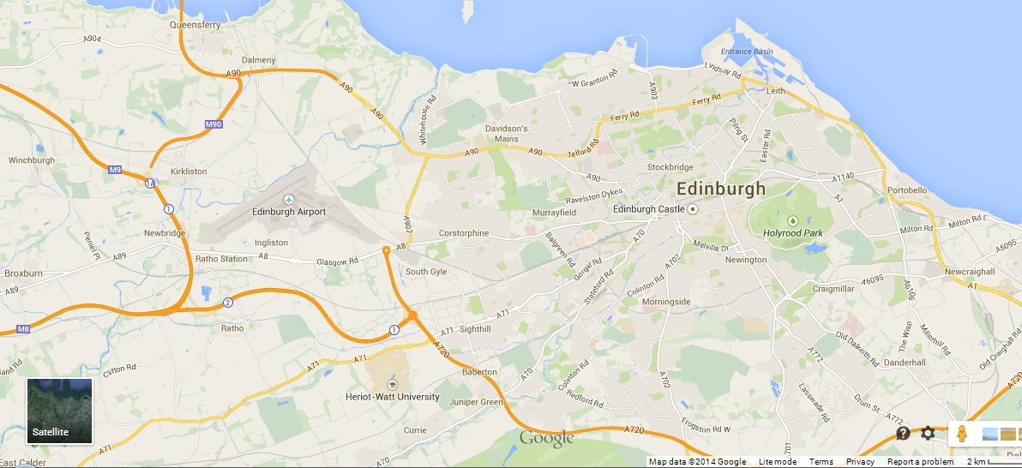
Map showing:

The location of The Spartans FC

Routes from Ainslie Park:

North – Forth Road Bridge A90
South – Berwick upon Tweed A1
West – City Centre

Map and directions from Edinburgh airport
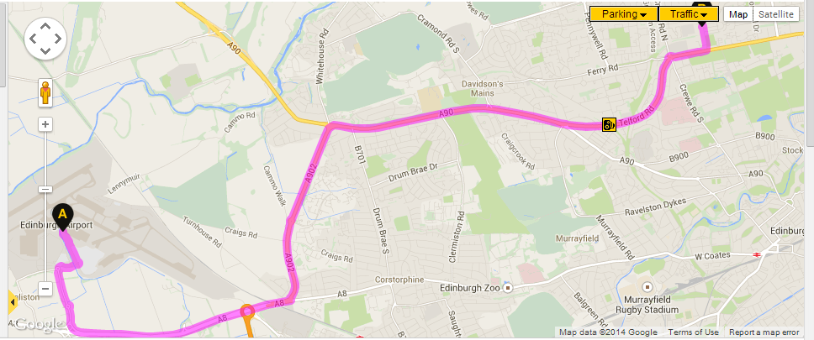
 | Start out on Gogar Bridge Road
At roundabout take the 2nd exit onto Eastfield Avenue
Exit All Routes

At roundabout take the 2nd exit onto Eastfield Road
Exit, All Routes

At roundabout take the 1st exit onto Eastfield Road
Edinburgh, Glasgow, Stirling

A8 |  | At roundabout take the 2nd exit, then merge onto the A8  Edinburgh, City Bypass
A902 |  | At Maybury Junction, traffic signals turn left onto the A902  Leith
At roundabout take the 1st exit onto the A902
Edinburgh North, Leith

A90 |  | At Barnton Junction turn right onto the A90  City Centre
Quality Street Junction, at traffic signals continue forward
City Centre

A902 |  | Branch left, then merge onto the A902
 |  | Warning: Speed Cameras along the A902
At Crewe Toll roundabout take the 3rd exit onto the A902
Leith, Granton

At traffic signals turn left onto Pilton Drive
Superstore, Leisure Centre

 |  | Arrive on unnamed road

Map and directions from City centre
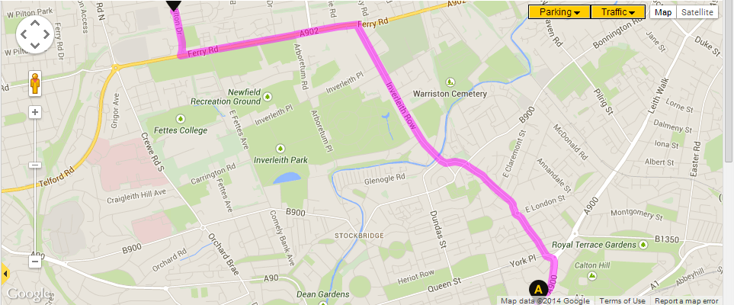
 | Start out on Waterloo Place
A900 |  | Wellington Statue, at traffic signals turn right onto the A900  Leith
B901 |  | At Picardy Place Roundabout take the 1st exit onto Picardy Place - B901  Forth Road Bridge A90, Glasgow M8, Carlisle A702  then immediately
 |  | At traffic signals bear right onto Picardy Place - B901
 |  | At roundabout take the 2nd exit onto Mansfield Place - B901
B900 |  | At traffic signals continue forward onto Canonmills - B900  Royal Botanic Gardens, Warriston Crematorium
B901 |  | Show Map | Hotels | Restaurants  Bear right onto Canonmills - B901
A902 |  | At traffic signals turn left onto the A902
At traffic signals turn right onto Pilton Drive
Superstore, Leisure Centre

 |  | Turn left
 |  | Arrive on unnamed road

Map and directions from A1
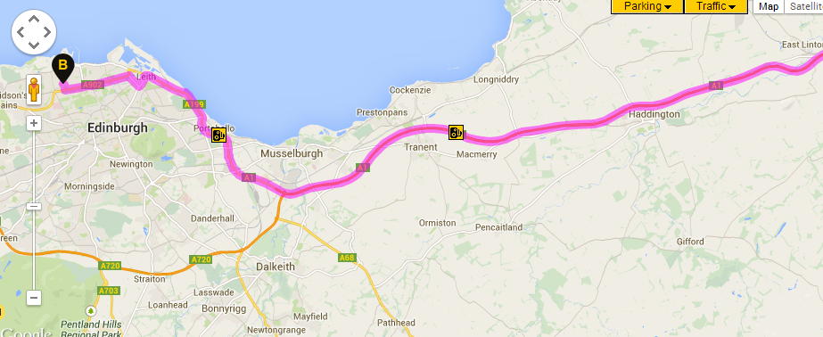
At roundabout take the 2nd exit onto the A1
Portobello, City Centre

A199 |  | Milton Link Junction, at traffic signals continue forward onto the A199  Portobello, Leith
 |  | Warning: Speed Cameras along the A199
A900 |  | At traffic signals turn left onto the A900  Local Access Only
A901 |  | At traffic signals turn right onto the A901
A902 |  | At traffic signals turn left onto the A902  Forth Road Bridge, Glasgow
Show Map | Hotels | Restaurants
At traffic signals turn right onto Pilton Drive
Superstore, Leisure Centre

 |  | Turn left
 |  | Arrive on unnamed road

Public Transport
Buses from town
19,27,37,47
Get off the bus at the Morrison’s supermarket on ferry road, before the Crewe toll roundabout and walk 5 minutes down Pilton Drive and take a left into the Edinburgh Leisure complex at Ainslie Park, and Spartans FC are situated at the far side of the complex.
Lothian buses website: http://lothianbuses.com/
Visiting Team Coach
- Parking Available at Edinburgh Leisure car park at Ainslie Park
Vehicle Parking
- Spartans parking reserved for players, officials and directors
- Spectators can use Ainslie Park car park, Pilton Drive, the Morrison’s supermarket car park
- Disabled Parking is available within the Spartans FC car park

Review and Communication :
The traffic management plan will be reviewed annually/end of season or when any major road changes, train or bus routes get altered which will affect a safe and easy journey to the facility.
Information can be communicated to customers via the Spartans website.

Contacts

By Mail:
The Spartans Community Football Academy
Ainslie Park
94 Pilton Drive
Edinburgh
EH5 2HF

By Phone:
0131-552-7854

By E-Mail
info@spartanscfa.com

